Caltech Jan 1970-August 1970

My move to Caltech was the beginning of my involvement with infrared astronomy which became the theme for the rest of my career and in which I feel I was able to make some significant contributions.

The Move West

My MIT appointment in x-ray astronomy came to an end in September 1969. I was hoping for a post-doc position at UC San Diego in Peterson’s x-ray group and was disappointed to find that he had been stringing me along because he had another candidate who he preferred and to whom he eventually gave the position. My former SM supervisor, Frank Scherb at the University of Wisconsin, had some money left over in a grant for stellar interferometry and supported me for two months. Mostly I was living free at the Agassiz Station of Harvard College Observatory and spending any clear nights with Jim Elliot on interferometry.

I am not sure how the contact with Gerry Neugebauer was made but possibly it was through Eric Becklin who was then at the Smithsonian, having just left Caltech. He occasionally did some observational work at Agassiz. Neugebauer was interested in the possibilities for stellar interferometry in the infrared.

I was offered a post-doc by Gerry (not to be pronounced Jerry!) and I headed West towards the end of December. Ironically, as I left Massachusetts it was at its most wintry beautiful. The sky was blue and the trees were covered with icicles glittering in the Sun. I spent Christmas with the Ogilvies in Washington and a couple of nights with Jim Elliot’s family in Columbus, Ohio. Then I drove about 500 miles a day westwards in my MG, except for one day when I had to hole up in Oklahoma because the roads were snowed in and there were jackknifed trucks everywhere. I passed through Flagstaff and went to look at the Grand Canyon. Arriving in California seemed like another country. Gone was the wintry weather and all was sunshine.

On arrival in Pasadena I sought out Gordon Garmire, a former student in the MIT Cosmic Ray Group, who was then an Associate Prof of Physics at Caltech. He was mainly into x-ray astronomy and his wife Elsa was in lasers. They kindly let me stay with them for a week or so while I searched for an apartment of my own.

I found a place to live on Hurlbut St, near the end of the Pasadena Freeway. My landlady was a refugee from the Chicago winters. Her daughter of 26 had been a “Rose Princess” at the famous Rose Bowl parade and, according to her mother, had never yet been married, unlike the other princesses, most of whom had already been divorced at least once. So what was wrong with her?

Neugebauer’s Group

Neugebauer’s group was located in the newly–constructed Downs Laboratory.
At the time, there were graduate students from both Physics and Astronomy – Paul Harvey, Bob Toombs, Jay Frogel (a student of Guido Munch). Harry Hyland was an Australian post-doc from astronomy who did mostly infrared spectroscopy in the 1.6 and 2.2 micron bands (as did Frogel). Michael Penston from England was a post-doc based at Santa Barbara Street (where Mt Wilson was run from). There was a technician – Gordon Forrester, a secretary and a data processor lady, Judy Bennett. Various impecunious undergraduate students, some of them very bright, assisted with observing. Among them was Henry Tye, later famous in cosmology. Another was Harvey Butcher who also became a well-known astronomer. Eric Becklin had just left and now and then Neugebauer would remark “Too bad Eric had to leave” when he wanted to make me feel bad. In general, Neugebauer was a bit of a slave-driver and not always liked by those around him. Some of his time was spent at Jet Propulsion Laboratory where he had several space experiments on the go.

Neugebauer owed his initial success to the Two Micron Sky Survey (its detections were known by IRC numbers) that had been initiated by RB Leighton. Although infrared photometry in the same wavelength region had been started by Harold Johnson of Arizona, for the most part the only sources known about in the early 1960s were relatively ordinary stars with predictable infrared characteristics. The IRC survey showed that there are large numbers of objects that have very strong “infrared excesses”, or infrared luminosities in excess of what would be expected from ordinary stellar photospheres.

Observations were made at the Mount Wilson and Palomar observatories. Access to the 200-inch, then the largest in the world, was jealously guarded and shared between the favoured few who worked at Caltech or Santa Barbara Street (the headquarters of the Mount Wilson Observatory, belonging to the Carnegie foundation). Nights were usually given out 3 at a time on the larger telescopes but were fairly easy to obtain on the smaller ones.

Before an observing run, a list of objects to be observed was prepared. This involved making finding charts and precessing the positions to the observing epoch (no TV acquisition or “go to” telescopes in those days). Standard stars were taken from Harold Johnson’s lists, with the H-band magnitudes interpolated from J and K.

The infrared equipment, of which there were two sets, was kept in the lab at Caltech. Before each observing run one went through a long checklist and filled up a set of wooden boxes with the cables, electronics, toolboxes and other accoutrements required. An observing run was fairly hectic because the equipment had to be mounted on the afternoon before the first night and dismantled immediately after dawn on the last one. Then there was the drive down the mountain and however tired you were Neugebauer expected you to appear in the lab by 11 am!

Technical aspects of photometry as then practiced

Most of the more routine observations were made in the JHKL broad bands (1.25, 1.65, 2.2 and 3.4 microns). The detectors were photoconductive PbS type and suffered from 1/f noise (a type of contact noise arising from the granular nature of the chemically-deposited PbS). The cryostats were fairly primitive and did not have changeable filters inside. The best one had a cut-off filter at the end of the 2.2 micron band and had an overcoated silicon field lens which limited it to the 1.6 and 2.2 micron bands. Usually it could be interchanged with a less efficient cryostat that could be used at all four bands (Silicon has a very high refractive index and therefore high reflection losses if not overcoated). The filters and apertures were external to the cryostats and a rotating sectored-mirror chopper operating at a submultiple of the mains frequency was used to overcome the 1/f noise and at the same time avoid pick-up from the 60Hz mains power and the powerful TV stations on Mt Wilson.

The sectored-mirror chopper caused the detector to view a piece of sky containing the object of interest (the “star position”) alternatively with a blank piece of sky, the “sky position”). The feeble audio-frequency signal from the cryostat was first fed to a preamplifier on the cryostat itself and then through a double-shielded cable to a synchronous detector (lock-in amplifier). The reference signal was derived from the position of the chopper. The output of the lock-in, which was of course an analog signal, was fed to a chart recorder but also to an integrator consisting of a voltage-to-frequency converter and a scaler. The scaler output was counted (integrated) for 10 or 20 seconds and then the telescope was moved so that the star and sky positions were interchanged. The scaler output was printed on a paper strip after every integration. I think that only in the case of the 200-inch was an automatic punched-card recorder available. The time required to achieve a given signal-to-noise was more or less dependent on conditions but could be estimated from the number of apparent detections and non-detections in a long series of sky + star and sky – star differences.

One person worked at the telescope and performed the star-sky interchange every 20 seconds by moving it a small amount in declination. This was achieved by using an offset guider and the handset buttons. An assistant had to keep a record on the printed paper strip and make notes as to the object name, gain, wavelength, aperture etc.

Back in the laboratory, the printed paper tape data had to be typed onto punched cards (and checked) for further processing on a computer. I used an adaptation of this programme for my photometric work later on in England and South Africa.

Recollections of Mount Wilson

One lived in a building situated on a steep spur of the mountain, named the “Monastery” by Hale because it reminded him of mountaintop monasteries in Greece. The Mt Wilson monastery was fairly decrepit and looked as if Hale had just left. On the walls were water colours by AA Michelson. The area, though close to Los Angeles, was sufficiently wild that occasionally coyotes or snakes might be seen.

The dining room seating was according to a rigid protocol, with the 100-inch observer at the head of the table and the 60-inch observer on his right side and so on down. Neugebauer used to boast that shortly before my time he had succeeded in getting abolished a rule that the diners had to wear jackets and ties!
The bedrooms were exceedingly cold and had feeble and dangerous gas heaters that were too risky to actually use. Ladies were not allowed to stay in the monastery but were accommodated instead in the “Kapteyn Cottage” nearby.

Midnight lunch was provided in a picnic basket which it was the 100-inch (or was it the 60-inch?) observer’s duty to carry up from the monastery to a `’galley” situated between the two main domes. One observer told me that he had once offered to carry the basket for the aged Walter Baade but the latter had insisted it was his right to carry it!

There were 3 night assistants who took it in turns to operate the telescopes. They, and sometimes I, took time off in the middle of the night for a meal and we often had something simple like fried eggs and bacon.

Very little had changed on Mt Wilson over the years. Downstairs in the 100-inch was the original interferometer beam used by Michelson, for example. The DC electrics of the telescope were ancient and unreliable. Sometimes one of the big old relays would stick and have to be prodded with a wooden pole. The RA axes of the telescopes were supported in mercury baths to take most of their weight. The 100-inch baths had leaked through their cast-iron walls and the whole place was contaminated with mercury. The setting circles were read through a complicated periscopic system from the night assistant’s control desk. The chief assistant, Gene Hancock, knew the setting errors pretty well and could set the telescope fairly accurately. We used a “bent Cassegrain” focus at the side of the telescope. This was accessed from a highly dangerous mobile platform from which Alfred Joy had once fallen off. I was told that the State safety authorities would have closed the place down long before had they known about the conditions there.

The gradual emptying of the mercury baths had caused too much weight to rest on the bearings of the 100-inch and as a result the movement on RA had become jerky. However, the Director, Harold Babcock, was unconvinced and told people that complained not to use the telescope. It was only when Margaret Penston took a Newtonian plate, trailed in declination, that he had to accept the evidence. I believe that the tanks were then drained and epoxy-coated on the inside. Jay Frogel informs me that he could sometimes hear drops of mercury falling down.

I used the 60-inch telescope from time to time. It also had a bent Cassegrain optical system, accessed from a perilous observing “chair”. Though the declination drive had been rebuilt shortly before, it suffered severely from backlash. Once while searching for an infrared source in the daytime I pointed the telescope rather near the Sun and saw some smoke rising from the wiring at the top end. The quickest way to save the situation was to close the main mirror!

Other buildings on Mount Wilson included the unsuccessful 50-foot interferometer of Michelson and Pease and a 24-inch telescope belonging to the Caltech Geology department and used by planetary astronomers. I used the latter for some experiments in stellar interferometry, the seeing conditions on Mt Wilson being among the best in the world (when it was good). The interference fringes were much steadier than in Massachusetts and could be seen with apertures 50 cm or so apart. However, they still moved around a lot. The Mount Wilson results were published (AJ, 77, 523, 1972).

The 62-inch spun-epoxy mirror infrared telescope designed by Leighton that had been used for the IRC survey was still there and being used for various experimental programmes, I think relating to polarization. Leighton gave me a paper about how the mirror had been made and showed me the setup he was using to try to construct a 120-inch using a similar technique. I think that this was abandoned in the end.

When I worked with liquid hydrogen, the cryostats had to be filled in a draughty shed with the usual primitive electrics. I was always afraid that a spark might cause a hydrogen explosion. It was said that snakes also liked lurking in this shed.

The steady seeing was a consequence of the temperature inversion that was also responsible for the smog that usually blanketed the Los Angeles area. However, the city lights below had spoiled the site for faint object work. One often in the morning saw the peaks of the San Gabriel mountains poking out above the smog like islands. Harry Hyland, who used a type of Ebert-Fastie spectrometer in the 1.6 and 2.2 micron bands, told me once that he saw absorption features due to the smog in stellar spectra but Frogel says he never did.

The mountain staff had developed the kinds of exaggerated personalities found in such places. The “Mountain Superintendent”, Ben Traxler, had a fiery personality and everybody took care not to cross him. The mountaintop was shared with a number of TV stations and was also open as a viewpoint over Los Angeles to the general public. The youngest night assistant, a Vietnam War veteran, found an intruder in his house one afternoon and marched him at gunpoint to the gatehouse, past members of the public looking on!

The Mount Wilson summit was festooned with powerful television stations to serve the Los Angeles area. These were a serious nuisance to the infrared astronomers because the strong RF signals were easily rectified by the detectors and pre-amplifiers. Double-shielded cables often had to be used.

There was a little-used library on the mountain also. I found there a copy of the “reprint” in Astrophysical Journal style of the spoof Chandrasekhar paper “ On the imperturbability of elevator operators” by S. Candlestickmaker.

The workshop still featured an overhead shaft that drove the machines through belts. One of the technicians made a point of keeping the 1-cylinder diesel engine in running order and even started it for me one day. It had been used to generate DC electricity in the old days. The starting process relied on a large compressed air reservoir.

Palomar

Palomar, owned by Caltech, was much further from Pasadena. Visiting the 200-inch was very special in those days as it was the largest and most famous telescope in the World, accessible only to a favoured few from Caltech and Mount Wilson. Like the latter, accommodation was provided in a “Monastery”, though a more comfortable one.

The architecture of the 200-inch was spectacular. Its simple elegant lines made it something like a scientific cathedral. I never had the opportunity to look through the telescope myself. Neugebauer rode in the “Cassegrain Cage” and operated the photometer and my job was to sit in the control room with the night assistant, Gary Tuton. There was a “data machine” which read the output of the counter-timer and put the reading on punched cards. A series of alphanumeric thumbwheel switches has to be manipulated rapidly to enter the name of the object, its position, the aperture and the filter as a header on each card. The telescope itself was unchanged from its construction and its position was read by Selsyn-type indicators.

Neither the 100-inch nor the 200-inch had been aluminised for many years and as a result had become seriously inefficient. One could see through the 100-inch primary except where birds had marked it. I think this was brought home to the observatory authorities when Warner and Nather using the Texas 84-in showed that they were collecting more photons from the Crab Nebula pulsar than the 200-inch. They sarcastically referred to the 200-inch as “the largest 84-inch telescope in the world”.

The sky was much darker at Palomar than at Mt Wilson but was just beginning to suffer from distant street lighting.

There was a 20-inch telescope there that I used for long wavelength experiments on a few occasions. In addition there was the famous 48-inch Schmidt and the 18-inch. I had to bring liquid hydrogen with me, using liquid nitrogen containers. This was quite dangerous as liquid hydrogen is much colder than the freezing point of the atmospheric gases. On one occasion I found on arrival that the neck of the storage vessel had frozen solid with air! With great trepidation, I broke open the Styrofoam stopper with a screwdriver and released the pressure. I got choked off afterwards by Neugebauer for ruining the stopper!

My work at Caltech

I soon started going to Mt Wilson and Palomar Observatories as assistant to various of the others in the group and this way learned some good observing techniques. Infrared work was usually done in the bright-of-Moon periods. Most of the other astronomers that I met were users of the coudé spectrographs.

The infrared field was then new to me and I had a lot to learn. Neugebauer took very little trouble to orientate me so I had to do my best to teach myself. Jim Westphal, from Planetary Science, was pretty friendly and helpful and I learned a lot from him. I also got on well with RB Leighton who had done most of the writing up of the famous Feynman lectures.

I was set to work to develop an improved chopper device for working at longer infrared wavelengths, where the atmosphere, telescope and photometer all radiated strongly. The sectored rotating mirror system used up to then was unsuitable at these wavelengths because the edges of the mirror diffracted spurious radiation into the beam as they passed through the detector’s field of view.
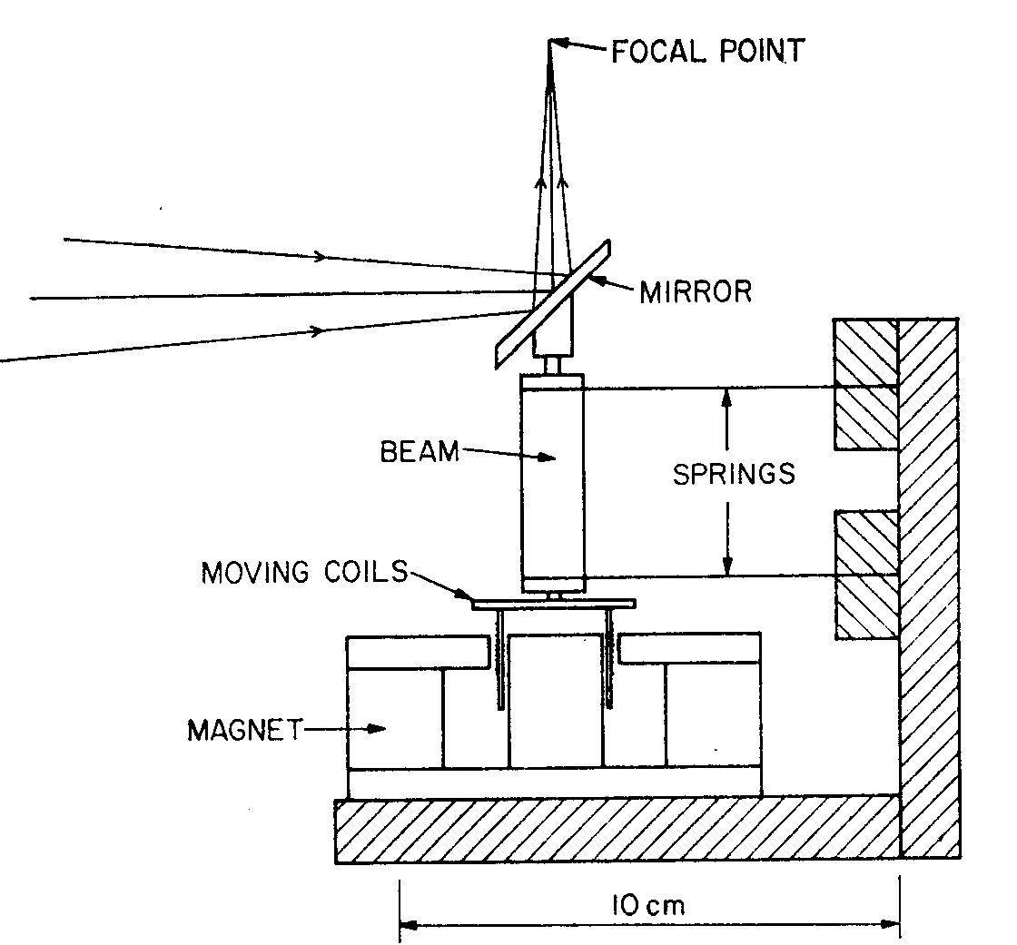
Fig: Stepwise oscillating chopper. The springs could be adjusted so that the mirror moved strictly parallel to itself so that the detector always saw precisely the same pupil.

I developed a stepwise-oscillating mirror driven by a loudspeaker-type moving coil and with a pickup coil for velocity feedback. It was mounted on parallel springs so that it moved strictly parallel to itself and did not see different parts of the telescope in its two positions. I published a short paper on this in The Observatory (92, 140, 1972). [Later on I refined this system by using a magneto-resistor as a position sensor to give better control].

I also built a small photometer in which to mount the new chopper. In the course of this work I learned to make my own mechanical drawings as the official drafting service at Caltech was too expensive to use. However, I did not do much of the machining myself.

I also worked on trying to get better performance out of various doped germanium detectors that were then used for long-wavelengths. These were quite noisy photoconductive devices and were cooled together with their field lenses and filters to around 24K using liquid hydrogen. There were not many bright stars observable at 10 microns with this equipment and the standard stars that we used were often variables, so it was difficult to judge sensitivities. I don’t think I achieved much here. It soon became obvious that for broad band photometry at the longer wavelengths (5 to 20 microns) the helium-cooled germanium bolometers developed by Neugebauer’s arch-rival, Frank Low of Rice University, were superior.

What I learned at Caltech

The main thing that I learned was how to prepare for an efficient observing session and how to reduce the data from that session timeously.

It is one thing to make a piece of equipment work in a laboratory and quite another when at a remote location and virtually in the open air. A rigorous observing procedure, careful record-keeping and systematic calibration and reduction are all necessities. Totally clear weather is also essential for photometry and sometimes even then the seeing conditions (unstable image size) preclude accurate work.

I made a copy of Neugebauer’s data reduction programme which I and others later adapted for use on various computers in England and South Africa.

Just before I left Caltech, Eric Becklin visited the group and showed off a photometer cryostat for JHKL that he had designed when in Massachusetts. This was of a much better design than Neugebauer’s equipment, especially in that the unwanted background radiation was almost eliminated. When I came to design my own photometer later, I made use of some of his ideas. He also adopted the polygonal cryostats sold by Low’s company that made it easy to add electrical feed-thrus and rods to control filter wheels etc.

Life at Caltech

I enjoyed Caltech outside my work more than MIT. For one thing, the California climate was much better. I fell in with a sociable group of post-docs and grad students (Jay Frogel, Larry Benowitz, Jacobo Bielak, Harry Hyland) with whom I often went out to dinner. Unfortunately, once again, there were very few girls around!

One favourite diner spot was Kabakians, an Armenian restaurant run by four brothers, that we must have visited at least once per week. It was not very well-known at the time. Once we were in a hurry and asked that they served us quickly. They were terribly offended by this and just plonked the plates down. The next time we went, we presented them with a bottle of brandy to make up and they were good friends after that. Sometimes in the middle of a cloudy night we might go to Cantors Deli in Hollywood, about the only place that remained open all night.

Caltech was much smaller than MIT – I think about 800 or 900 each undergraduates and grad students. Some of the well-known professors at Caltech were not shy to socialize with the students. I remember meeting Max Delbruck for example at a grad student party given by an Irish friend. I never met Feynman, though I saw him about and at colloquia. He asked a stupid question at one such – why did a certain reaction not go – and the answer was “Conservation of momentum, Prof Feynman”, which got a big laugh.

I met Gell-Mann at least once, at some lunch in the Athenaeum. He told a story that while at the Nobel prizemans’ dinner he had complimented the king of Sweden on his choice of wine. “It was the last of this wine”, he replied, “and we wondered if we should serve it to a group of people who might not appreciate it. Can you believe, we had one person a few years ago who only drank orange juice“. Possibly that had been Feynman.

The astrophysics seminars were sometimes enlivened by the presence of Fritz Zwicky in the back row. He was apt to make remarks “Already in 1931 I pointed out …” Wal Sargent loved to refer to “the high priests of American astronomy and their sycophants”, one of Zwicky’s choice phrases. Zwicky had been banned from observing when he reached retirement age, which I thought was very unfair.

Victor Neher, one of the “greats” of cosmic rays, gave his “Swan Song” lecture while I was there.

Most days there was a lunch to attend with one or other interest group – for example Downs Lab had a packed lunch day, we went on Wednesdays with I think the astronomers to Miharis, an open air Mexican place and on Fridays there was an astronomical lunch at the Atheneum, a slightly formal venue. In the latter I met many physicists and astronomers, including Gell-Man, Tammann, Schmidt and others.

It was usually an apolitical campus. However I remember an open-air lunchtime talk one Wednesday by Angela Davis, a left-wing political activist who was notorious at the time for her involvement with the black radical “Soledad brothers”. I was standing next to RB Leighton who remarked that he had not seen so many students at Caltech protesting since they took Star Trek off TV.

Linus Pauling was another Caltech star who I heard lecture – I think on the virtue of drinking lots of orange juice.

I also met at some lunch Prof Haagen-Smit who was the chairman of the Los Angeles pollution authority (or something similar). He told me that the chemical industries in the LA basin were at least as responsible as the cars for the appalling pollution problem.

On one occasion I saw Robert McNamara strolling through one of the cloisters with some Caltech officials. This must have been about the only campus that he could have visited without causing a student protest, as he was one of the chief architects of the Vietnam War.

Southern California Miscellany

While at Caltech I managed to make a few short trips to places in the greater Los Angeles area. I made a trip up the coast to San Franscisco, where I had a friend, David Wilson, from Dublin, who was studying for an Electrical Engineering PhD at Berkeley. I had an invitation to stay over at Pebble Beach, a famous golf enclave, and went also to Carmel. Another friend, Ken Brecher from MIT, was at San Diego on a post-doc with Geoff Burbidge.

I recollect going to a concert at the Hollywood Bowl with Ravi Shankar on the Sitar. There were interesting concerts and other events at the Beckmann Auditorium on campus but I don’t remember any particular ones.

I even visited Disneyland, Hearst’s San Simeon castle and the Briggs-Cunningham Auto Museum. The latter had an exceptional collection but was closed in 1987.

In Pasadena I visited the very fine Huntingdon Gallery, library and and botanic garden on a couple of occasions. This was quite close to Caltech, in the neighbouring district of San Marino, and, like Caltech and Mt Wilson Observatory, was part of GE Hale’s cultural legacy.

When the Downs/Lauritsen building, where I worked, was opened officially, there was a Bach concert given by Rosalyn Tureck, who had been a friend of the Lauritsens. She was unexpectedly asked to give an encore, in which she made some mistakes.

My 1968 MGB roadster was ideal for the California climate. When I left, I sold it to Glenn Veeder, an astronomer at the Jet Propulsion Lab.

Leaving Caltech

My US visa had expired shortly after I got to Caltech. It was an “Exchange Visitor” type, which I had foolishly taken in 1961 because it was the condition for a travel grant. However, it came with the rider that one had to leave the US 18 months after one had got one’s degree and stay away for at least 2 years. There were very few loopholes in this law and I investigated each one of them. In fact, I found a congressman who was prepared to put a private bill before Congress on my behalf in exchange for a payment, but I decided I would rather leave than stay on with Neugebauer, who I don’t think liked me anyway.

Michael Penston, then about to return to the Royal Greenwich Observatory, persuaded me that I should apply to go there. He had been working on infrared photometry of active galaxies using Neugebauer’s equipment and was very keen that RGO should set up for infrared photometry. I had an interview with Donald Lynden-Bell, who was then based at RGO and was visiting Caltech at the time, and received an offer of a Fellowship which I eventually took up. I also had an interview with Olin Eggen, Director of Mount Stromlo but had the impression, false as it turned out, that they were not interested. Before leaving I made sure I found out where to get the many specialized components that I would need in the future.

I left Caltech at the beginning of September 1970. I had built a number of wooden boxes for my books in the workshop of Downs Lab and I took them down to Long Beach to the docks and unloaded them onto the loading bay of the shipping warehouse. The longshoremen, who had a very strict union, would not touch them until they were inside the door! The actual cost of shipping them to London was surprisingly little.

Afterwards I went with Jay to a summer school mainly for Caltech and Berkeley students, camping at Tuolumne meadows in Yosemite. We had lectures in the open air, outside a mountain hut, from Allan Sandage, Maarten Schmidt, Peter Goldreich and others. This was a rare opportunity as Sandage was notoriously reclusive and was rarely seen.

After visiting the Ogilvies, then on holiday in Kitty Hawk, North Carolina, I headed back to Europe.

